**AN ASSESSMENT OF THE DETERMINANTS OF GROWTH OF SMALL RETAIL BUSINESSES THROUGH ONLINE SHOPPING IN LIMURU AND NAIROBI TOWN,**

**KENYA**

SPEAR NJOROGE NGUGI

DICT 744/09/016

A RESEARCH PROJECT SUBMITTED IN PARTIAL FULFILLMENT OF THE REQUIREMENT FOR THE AWARD OF THE DEPLOMA IN INFORMATEION COMMNUMINATION TECHNOLOGY IN THE DEPARTMENT OF ICT AT KABETE NATIONAL POLYTECHNIC.

YEAR 2019

# DECLARATION

I Ngugi Spear Njoroge declare that all content presented in this document is my own work developed under the supervision of Mr. Martin and has been presented as part of course requirement for the award of a diploma in Information Communication Technology.

**Student Approval**

**SPEAR NJOROGE NGUGI.**

SIGN: ………………………………. DATE………………………………..

**Supervisors’ Approval**

This research Project has been submitted for examination with my approval to my supervisors

**Mr. MARTIN**

SIGN………………………………………….. DATE: …………………………………………

**Mr. OMENDA.**

SIGN………………………………………….. DATE: …………………………………………

# DEDICATION

This project is dedicated to my Mom Susan njeri for her unwavering support and my whole family in general not forgetting all my friends who have assisted me different ways. I also take this chance to dedicate it to Kabete National Polytechnic’s information communication technology department for the skills they have instilled in me over the three year course.

Most importantly I dedicate this project to God, for his grace upon my life that has enabled me to finally complete my diploma successfully.

# ACKNOWLEDGEMENT

My journey to this point has been a rocky one and through it all, I have had some people who have been there for me through it all. I would first like to thank my family for their unconditional support with my studies and their constant motivation when thing became difficult both morally and financially.

I thank God for giving me the determination guidance and courage in conducting research on this project despite all the difficulties. I am also very grateful to my parent for supporting me every step of the way with their advice

I would like to humbly acknowledge my supervisor Mr. Martin for helping me to finish my project finally. He has been instrumental in the development of this project, and I appreciate that very much.

My deepest gratitude also go to Kabete national polytechnic for giving me the chance to pursue my diploma in Information Communication Technology and providing me with a workable environment for the three years.

# ABSTRACT

In today’s fast-changing business environment, it’s extremely important to be able to respond

to client needs in the most effective and timely manner If your customers wish to see your

Business online and have instant access to your products or services.

In this music instrument stores, records are manually kept making retrieval of information tedious and slowing and also becomes very difficult to update old records. This in turn slows down the overall operations of the business and the business stands to lose money and instruments.

This project aims at developing a web based application that will be used to retails various music instruments both hardware and software. It will allow viewing of various music based products available, and will enable registered users purchase desired products instantly using both M-PESA and bank payment.

It will also provide an easy way for Administrators and Managers to view customer orders placed and view indication as to whether they have been paid for or are still pending .it will make use of open source technologies such as (PHP, HTML5, CSS3, JavaScript, MySQL and Apache Web Server).

The proposed project will have two main views; admin view and the public or guest view. The admin view will enable administrator to update the products, change prices, remove and add products and also manage customers. The customer view will be accessible to the customers and will allow them to handle information such as their names, ad-dresses and their contact information all done in an easy to use web interface.

# TABLE OF CONTENT

Contents

DECLARATION 2

DEDICATION 3

ACKNOWLEDGEMENT 4

ABSTRACT 5

TABLE OF CONTENT 6

ABREVIATIONS AND ACRONYMS 7

LIST OF ABREVIATIONS. 7

CHAPTER 1 8

1.1 BACKGROUND OF THE STUDY 8

1.2 PROBLEM STATEMENT 9

1.3 RESEARCH OBJECTIVE 10

General objectives of the research. 10

Specific objectives for research. 10

1.4 RESEARCH QUESTIONS 10

1.5 THE SIGNIFICANCE OF THE STUDY. 10

1.6 SCOPE OF THE STUDY. 11

1.7 LIMITATIONS OF THE STUDY. 11

CHAPTER 2 12

LITERATURE REVIEW 12

2.1 INTRODUCTION 12

2.2 Price attractiveness 12

2.3 Time saving 13

2.3 High interactivity 14

# ABREVIATIONS AND ACRONYMS

## LIST OF ABREVIATIONS.

CSS-Cascading Style sheet

GUI-Graphical User Interface

HTML-Hypertext Markup Language

PHP-Hypertext Pre-processor

SDLC-Software Development Life Cycle

SQL- structured query language

# CHAPTER 1

Online marketing is fast gaining ground as an accepted and used business paradigm. More and more business are implementing web sites providing functionality for performing commercial transactions over the web which have been made possible by technologies such as email. It is reasonable to say that the process of shopping on the web is becoming commonplace.

## 1.1 BACKGROUND OF THE STUDY

Online marketing is an output of information technology applied to traditional marketing. Business environment, competition, market, customer needs have been changing over decades, demanding technological innovations in all spheres, including marketing activities. Thus E-commerce is a result of combining opportunities of the information technology sector, requirements of economics and business, as well as the possibilities of marketing. New on-line infrastructure brought traditional marketing to the next level, providing great opportunities for companies on value creation processes, introducing cost saving benefits, and increasing revenues. Internet has played a crucial role in development, acting both as a market and a medium, connecting different platforms.

Consumer behavior has evolved (digital marketing revolution) over the last few years. The consumer search for products and the buying process has evolved as a result of the development and growth of the e-commerce industry.( Apnest blog- Online shopping trends in Kenya - Robert Wachira)

Global consumer research firm Nielsen has tipped Kenyan retailers to go online, where about one out of every four consumers browse for products and services. The Nielsen Consumer Confidence and Spending Intentions survey released this week says there is a huge gap in retail e-commerce space yet a quarter of Kenyans use social media to find out about fast moving consumer goods brands. Bryan Sun, managing partner for Nielsen East and South Africa says retailers need to realize that to meet consumers’ need for speed and convenience will only be underpinned by innovation.

The most successful retailers will be those who adapt to changing needs and demand for products and shopping experience. The opportunity for growth is inspired by “on the go lifestyle” of Kenyans which creates the need for speed, whether it is the consumption experience (ready to consume), shopper experience (proximity and efficiency) and engagement experience, driven by a two-way interaction and easy-to-use apps.“By keeping an eye on the future, retailers will find pockets of growth and truly leverage Kenyans growing demand for greater ease, utility and suitability to meet consumers’ shifting needs and fluctuating confidence levels,” said Mr. Suniyu. (daily nation-annie njaga)

The objective of this project is to develop a general purpose e-commerce store where product both hardware and software can be bought from the comfort of home through the Internet. However, for Implementation purposes, this paper will deal with online shopping of music instruments.

An online store is a virtual store on the Internet where customers can browse the catalog and

Select products of interest. The selected items will be collected in a shopping cart. At checkout

time, the items in the shopping cart will be presented as an order. At that time, more

Information will be needed to complete the transaction. Usually, the customer will be asked to

Fill or select a payment option; online or offline payment, and payment information.

## 1.2 PROBLEM STATEMENT

As much as online shopping has huge benefits to both traders and consumers. Kenya and most African counties are still luging behind and only very few businesses have successfully put their products online

Putting a business online is a challenge to many small business owners since it is quite expensive to hire a web designer to develop a website .furthermore a hired web designer might not be properly knowledgeable of the business objectives and customer needs and might develop a website that does not fully satisfy the end users.to add to this the owner of the business incurs other charges like periodic maintenance costs. Some of this are the challenges my proposed system intends to fix.

## 1.3 RESEARCH OBJECTIVE

### General objectives of the research.

The main objective was to develop an online web application that would enable small business owners such as music instrument retailers get their products online by filling different product details e.g. images, prices, product description and uploading them into a database and allow easy use and modification of different elements of the web application to fit their needs.

### Specific objectives for research.

* To develop an easy way to use web based interface where users can search for product view the details of the product and order it without going to market.
* The searching product can be done by product category, manufacturer as well as latest product, view it purchase it become a convenient way for customer.
* Customer can add product to cart to purchase, delete the product from cart before selecting the final submission.

## 1.4 RESEARCH QUESTIONS

1. What is the current selling system in use?
2. Is there any online system that exists?
3. What are the main challenges you are facing with the current system?

## 1.5 THE SIGNIFICANCE OF THE STUDY.

The finding of the research will help develop a web application that will help different business owners minimize cost by reducing the number of employees. There will also be faster retrieval of business records and secure storage from unauthorized users. The proposed system will have an easy to use interface and will also calculate totals for different products and display them for the user in their cart. The records will accurately reflect in the admins dashboard allowing retailer deliver the right orders and keep stock of products available.

The findings of the research will also help future researchers who will be studying this field have a better idea of what the topic.

## 1.6 SCOPE OF THE STUDY.

The study will be conducted in Limuru and Nairobi town and will take a sample of 40 music instrument stores .Bellow is the scope of the developed system.

**For Customer**

**Online registration:** Customers have to register to buy product online.

**View Product:** Customer can view product according to category and latest products. Select the items to cart, also can delete from cart before final submission, they can also view product details, shipping info and price that means all in invoice.

**Shipping Information:** Customers have to give the product delivery location.

**Payment Method:** Customer can select the payment method that they are comfortable with.

**For admin:**

**Category:** admin can add categories, view, edit and delete category.

**Product:** admin can add product, view, publish, unpublished, edit manufacturer and delete product.

**Product delivery status:** Admin can update sold product status.

## 1.7 LIMITATIONS OF THE STUDY.

The researcher had some financial problems and could not cover all locations in Limuru and Nairobi. Thus the Research findings may not apply to all districts in the county since only some locations data was considered. Some of the people were not able to answer the asked questions correctly due to illiteracy and unwillingness to answer.

# CHAPTER 2

# LITERATURE REVIEW

## 2.1 INTRODUCTION

Online shopping is growing extensively on Internet.. Whereas some of people take these simple activities every day, most of them may not be familiar on how small businesses have use online-shopping as a business strategy to guarantee their survival in new global marketplace.

There are comprehensive literatures focusing on online shopping. Despite variations in topics and approaches, these authors have concluded that small businesses are increasingly using Internet and this will radically change the way businesses are and will operate their businesses in future as its advantages out way the disadvantages.

2.2 Price attractiveness

Price is a form of monetary that people use for any transactions. It is predicted that price of a product differs in online and offline shopping. According to Xia and Monroe (2009), consumers will save in monetary when there are price promotions on specific products. In an online context, consumers are more likely to depend on the price cues to determine the quality of a product which are presented in the web site because they cannot see or touch the actual product (Jiang and Rosenbloom, 2005). The study of So, Wong and Sculli (2005) resulted that when there is the presence of promotional offers, consumers will have higher intention to purchase in web-shopping; purchasing decisions and choice making from alternative evaluations can be made easily when there is the presence of promotional offers.

According to Xia and Monroe (2009), their study resulted that consumers with a shopping goal are more responsive towards promotional messages such as “pay less” and “discount” while consumers without shopping goal are responsive towards promotional messages such as “save more” and “free gift”. Xia and Monroe (2009, p.691) cited from (Monroe, 2003) that price promotion have several benefits such as to increase demand, adjust fluctuations in supply and demand, and increasing consumers’ purchasing over time.

As we know that online shopping requires shipping fees for product delivery. It is expected that some consumers intention to purchase a particular product because they have to pay extra charges for the delivery service. But according to Jiang and Rosenbloom (2005), e-tailers can use charges for shipping and handling as a tool to attract patronage by matching consumers’ delivery needs; for example, some consumers who would prefer a quick delivery will have to pay higher cost while others may prefer to wait if they pay lower shipping and handling charges.

2.3 Time saving

Time is also perceived as one of a factor that relates with intention to purchase in a shopping context. It is believed that consumers have their own perception of time, whether or not to shop from the internet. According to Hansen and Jensen (2009), accomplishing the shopping trip as soon as possible refers to the time-saving oriented consumers and they prefer store choices favoring quick shopping; people who dislike shopping and approaching for time saving retail stores refers to the economic shoppers or known as “problem-solvers”.

In online shopping, it requires less effort and better decision making for consumers who opt to purchase at the e-store (Jiang and Rosenbloom, 2005). Shoppers may save their time in e-shopping because they do not have to go through any effort on travelling to a mall or saving their time in other psychology factors such as traffic jam etc. Online shopping increases search efficiency by eliminating travelling costs and psychological costs brings convenience in e-shopping (Jayawardhena et. al., 2009). Comparing online and traditional shopping, Alreck and Settle (2002) found that internet shopping was viewed as saving more time.

Shoppers who value convenience can obtain the benefits of product and services with less effort and this would have a positive relationship with shoppers’ excitement (Jayawardhena et. al., 2009). Ordered products are directly delivered to the door is the greatest interest to many consumers because online shopping does not requires us to leave the hours or office (Chen and Chang, 2003). According to Monsuwe, Delleart and Ruyter (2004), the main drive of online shopping is that the internet is time saving and accessible 24 hours a day. Shopping in the internet saves time and effort because consumers are able to shop any time in the comfort of their home; especially for consumers who have little amount of free time because of extended working hours (Wolfinbarger and Gilly, 2001).

Consumers expect timely delivery in the online store as they browse and “internet shopping” is just alike as they visit the “offline stores” and they “create order transaction” just like they “purchase the product” (Ahn, Ryu and Han, 2004). In the previous study of Koyuncu and Bhattacharya (2004), the researchers found that online shopping offers better prices on the products and it allows consumers to shop more quickly than other shopping alternatives, and this will lead individual to be inclined to increase their shopping from the internet. According to Monsuwe, Delleart and Ruyter (2004), online shopping requires least effort, inconvenience and time investment for consumers to browse the whole product-assortment; consumers can make the correct decisions efficiently because they can gain vital knowledge about firms, products and brands.

Consumers also expected that product delivery in online shopping will be quicker compared to offline stores and timely delivery on their convenience time; factors that keep consumers satisfy in using internet as a tool for shopping is timely and reliable delivery (Ahn, Ryu and Han, 2004). Broekhuizen and Huizingh (2009) expected the relationship between time or effort savings and purchase intentions is strengthen; consumers will place more emphasis on the time and effort savings once they have experienced how little time and effort takes to make an online purchase. Liu, He, Gao and Xie (2008) suggested that to save customer’s time and fully reflect the convenience of online shopping, e- marketers should strengthen the web site’s transaction capability and make sure all operations can be completed online.

2.3 High interactivity

Interactivity is defined as the degree to which two or more communication parties can act on each other, on the communication medium, and on the messages and the degree to which such influences are synchronized (Liu and Shrum, 2002, p.54). According to McMillan and Hwang (2002), interactivity is defined as direction of communications, user control and time. Interactivity can be applied in online and offline shopping. The terms of interactivity in an online context is based on the detailed information given, easy-to-read or descriptive information is available (Park and Stoel, 2005) and also the degree of communication between the buyer and the seller. In an offline context, interactivity will be based on the atmosphere of the shopping mall and also the interaction between the consumer and the shop’s promoter.

To highlight the term of “atmospheric”, consumer’s purchasing probability is enhanced through purposefully design the buying environment to produce specific affective responses in shoppers (Kotler, 1973-1974). When purchasing on the internet, perceived trustworthy will be higher when the web site has greater interactivity (Merrilees and Fry, 2003). A citation has been done on Hoffman and Novak (1996) by Ballantine, (2006, p.463), there are two main types of interactivity are considered to be applicable to the web. The first, person-interactivity, is the ability for a person using the web to communicate with other individual. The second, machine-interactivity, refers to the ability for an individual to access hypermedia content.

Consumers are then able to make better purchasing decision because of the increased availability of information provided in the web site, causing a consumer to be more knowledgeable. (Cook and Coupey, 1998). The research of Ballantine (2006) resulted that the satisfaction of customer increases when the level of interactivity provided by an online shopping environment increase; and similarly the consumer’s satisfaction is also increased when the greater number of attributes provided on a per-product basis; similarly, Dholakia and Zhao (2009) agreed that the shoppers were more satisfied when there are higher interactivity level compared to lower interactivity level web site.

Research done by Dholakia and Zhao (2009) resulted that online shoppers’ satisfaction and behavioral intention is influenced by both objective and subjective interactivity. Objective interactivity refers to the types of communication mediums available in an individual website while subjective interactivity refers to perceived interactivity. To show that online vendors are customer-oriented, a quick response is requested to reduce uncertainty of the customers (Gummerus, Liljander, Pura and van Riel, 2004). Interactivity is also known as contact which refers to the availability of assistance through telephone or online representatives (Parasuraman, Zeithaml and Malhotra, 2005). However, Hansen and Jensen, (2009) found that customer have difficulties in selecting items because personnel advice is not available through the internet and this will prevent them from purchasing the apparel.

According to Chen and Chang, (2006), interactivity is one of the conditions to achieve flow; if there were inadequate interactivity, it will cause a company to occur lost. For example, consumers long wait for the system feedback and difficulty in maneuver within some Web sites that causes frustration; unreliable connection of system interruption from ISP will also cause frustration of the consumers. Response time of a web site is also very important as the speed in the interaction process will give users a negative perception if the response time is slow (Lin and Lu, 2000). In order to enhance interactivity in an online context, a web site should convey the excitement of shopping, attracting consumers to browse more and let them know more about the products than other shops (Demangeot and Broderick, 2006).

Lastly, interactivity is a factor that must be augmented in internet shopping. Various components of the shopping process that will affect one’s online experience ad overall shopping process must be aware by the internet marketers (Chen and Chang, 2006). Besides that, company representatives must be able to answer customer inquiries and solve problems as soon as they occur because customer lack of direct, face-to-face interaction with the service provider (Liu, He, Gao and Xie, 2008). Hansen and Jensen, (2009) suggested that company should provide personnel advice via chat rooms to provide guidance to the consumers so that it can mediate the effect of difficulty in selecting items

# CHAPTER 3

# RESERCH METHODOLOGY

## 3.1 INTRODUCTION

This chapter entails the methodology used for this project explaining in detail the targeted population, procedures used in data collection, sampling methods used, how data was analyzed and also defines the relationship among different entities.

## 3.2 RESERCH DESIGN.

Action research design was used for the study. The essentials of action research design as described by [‘Creswell, John W. and J. David Creswell’] follow a characteristic cycle whereby initially an exploratory stance is adopted, where an understanding of a problem is developed and plans and strategies are made. Then the "action" in Action Research follows next during which time, observations are collected in various forms. The new interventional strategies are carried out until a sufficient understanding of (or a valid implementation solution for) the problem is achieved. The protocol is iterative or cyclical in nature and is intended to allow deeper understanding of a given situation, starting with conceptualizing and particularizing the problem and moving through several interventions and evaluations. Other benefits of implementing this design include:

* Review and synthesize previously published literature associated with the research problem
* Clearly and explicitly specify hypotheses [i.e., research questions] central to the problem
* Effectively describe the data which will be necessary for an adequate testing of the hypotheses and explain how such data will be obtained.

## 3.3 TARGET POPULATION.

The study assessed music instrument stores in Limuru and Nairobi town. The study investigated different types of music instrument retail businesses dealing purely in hardware and/or software’s such as virtual studio technology instrument (VSTi).the number of store totaled to 40 where sampling survey was adopted .The categories are as follows:

**Types of music instruments retail stores**

|  |  |
| --- | --- |
| **TYPE OF STORE** | **NUMBER** |
| Music hardware based | 12 |
| Music software based | 3 |
| Both Music software and hardware | 25 |
| TOTAL | 40 |

Table 1: Types of stores studied

## 3.4 SAMPLE SELECTION AND SAMPLING PROCEDURE.

The collected data included both qualitative and quantitative. Thus, qualitative and quantitative data analysis was employed in the study, using the variables. Procedures such as cross tabulation were used in the analysis of the data collected.

Qualitative data which was collected through interview was analyzed through transcription and organization of data. This was then be continued by systematically analyzing the transcripts, grouping together comments on similar themes and attempting to interpret them, and draw conclusions.

Quantitative data will be analyzed through SPSS computer program system. These data will be presented in the form of graphs and tables. In order to establish a convenient comparative tool, percentage rates will also be used to present data.

3.5 DATA COLLECTION TOOLS AND PROCEDURE.

Questionnaires were used to collect data using prepared questions that were filled by different respondent from which conclusions were drown after careful analysis. Observation was also used to determine different challenges different stores were facing using the existing system and after analysis identified the best way to solve them through the proposed system.

3.6 RELIABILITY AND VALIDITY.

### 3.6.1 Reliability

**Reliability**simply refers to the consistency of a measure.According to Orodho (2004) reliability in research concerns the degree to which a particular measuring procedure gives similar results over a number of repeated trials. In order to test the reliability of the instruments I will use the test-retest method. This was done by administering the same instruments i.e. the questionnaire twice to the same retailers, and by waiting for a period of two weeks before administering the research instruments for the second time. Then the correlation coefficient of the response from both tests will be compared in order to establish the extent to which the contents of the questionnaire are consistent in eliciting the same responses every time the instrument is administered.

### 3.6.2 Validity

**Validity** is the extent to which the scores from a measure represent the variable they are intended to. But how do researchers make this judgment? We have already considered one factor that they take into account—reliability. When a measure has good test-retest reliability and internal consistency, researchers should be more confident that the scores represent what they are supposed to. Validity is mainly used to establishing whether the right questionnaire content is measuring what is is intended to measure. The content validation will be found appropriate in determining the extent to which the set of items provides relevant and representative sample of the domain of tasks under consideration therefore ensuring that data collected using various instruments represents the content area under study. This will include identifying the relevant items for each of the instruments used in the study.

3.7 DATA ANALYSIS AND PRESENTATION.

The study involved both quantitative and qualitative data. The study examined the collected data to make inferences through a series of operations involving editing to eliminate repetitions and inconsistencies, classification on the basis of responses and subsequent tabulation for the purpose of inter-relating the variables. Once the data was checked for completeness ready for analysis, it was coded according to the themes researched on.

The refined quantitative data was be analyzed using descriptive statistics involving frequencies

and percentages to determine concentrations. First, regular analysis with comparison among questions was be done using frequency analysis. This made it easier to quantify and establish the variations in the number of counts observed per variable. The second part of the analysis was to establish the causal relationship among the variables. In general two variables x and y are said to be linearly related, if there exists a relationship of the form: y = a + bx. On the other hand the relationship between two variables is said to be non–linear if corresponding to a unit change in one variable, the other variable does not change at a constant rate but changes at a fluctuating rate. Such a relation may be of the form: y = a + bx + cx2. In this study a linear regression model was used to investigate the relationship between growth and its various determinants. The study was to investigate the causal effect of businesses putting their products online. Growth in this study was be measured by income. The determinants to be considered are, technology, capacity building of the staff, and product innovation.

3.8 SOFTWARE DEVELOPMENT LIFE CYCLE

The proposed system incorporated the waterfall development approach during its development. It is a sequential development approach, in which development is seen as flowing steadily downwards through the phases of requirements analysis, design, implementation, testing (validation), integration, and maintenance.

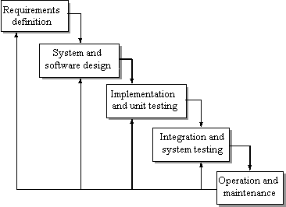

Figure : waterfall approach development cycle

### 3.8.1 Requirement definition

This is the first phase the analyst faced .at this phase the analyst identified all the fundamental process required during the development of the proposed system At this stage questions such as whowill use the system, whatthe system will do, and whereand whenit will be used were carefully analysed. In addition the current system was investigated, identified improvement opportunities, and developed a concept for the new system. This took place when the company was visited; an interview was conducted with people at the operation level as well as the management level including some of the staff. It was at this phase that the analyst identified user requirement keenly from the staff done through different facts finding techniques.

### 3.8.2 System and software design

In this phasea decision was made on howthe system will operate, in terms of the hardware, software, and network infrastructure; the user interface, forms, and reports that will be used; and the specific programs, databases, and files that will be needed. After that the coding of the system begins although most of the strategic decisions about the system will be made in the development of the system concept during the analysis phase, the steps in the design phase will determine exactly how the system will operate

### 3.8.3 Implementation and unit testing

Testing was based on two major units, customer user and Management Units. The customer test proved that an account could be created and could be logged into. The cart could be loaded with products and the customer could checkout after shopping. The test also verified that an administrator could create an account and log successfully. After login in it was verified that admin could manage all the content in the shop i.e. by performing operations such as adding products and editing them , managing users I.e. by adding and deleting them , adding and editing products as well as deleting them etc.

Some types of testing that were conducted Inc.:

#### Unit testing

This is testing of individual units; it checks errors on every unit that makes the program e.g. interface errors, syntax errors, etc. it focuses on verification.

#### Regression testing

This is where the software product is commissioned. The customer may discover errors or suggest enhancement of some features in the system. This test deals with correction of errors reported or enhancements enhanced. This test is always an automated process that runs a set of new test cases known to exercise the entire system. In case of the functionality a set of new test case are added to the test case.

#### User acceptance testing

This test determines whether the user of the system will accept the system and whether they will be able to use it to be more productive. He test will be carried out at users’ premises before it’s fully installed and implemented. A user will be trained on how to use the system and then he/she will be requested to use the system to see whether the user has any problem with its operation i.e. adding , deleting, saving, navigation etc

### 3.8.4 Integration and system testing

After through testing the system was installed in a real working environment at melodica music store and was tested with real live data to find out where its output was as expected and that the user requirements were met.

3.8.4 Operations and maintenance

This is the method of collecting reviews or systems revision to ensure the new systems performance is satisfactory. In this phase, system modification is made after the system is operational. Various methods will be employed for the maintenance of the system eg.

#### Adoptive maintenance

This will be done after every year of operation by the system developer in order to make the system respond to change in the user requirements. It involves upgrading the system to adapt to the changing environment.

#### Corrective maintenance

This will be done after every 3 weeks by the computer technician. It will involve fixing of errors encountered during its operations.

#### Perspective maintenance

This involves frequent reviewing and checking of the system for preventive measures in case of failures or breakdown that might occur in future.

# CHAPTER 4

4.1.1 CURENT SYSTEM

In 98% of all small business the study was conducted upon, it was identified that they were using manual operating their businesses by keeping stock records in books and files which occupied a lot of space. Some of them in various interviews that some records were getting misplaced and the businesses were incurring losses due to other disadvantages of manual system eg miscalculation of finances. Some also suggested the level of security was low while using the manual system and updating records was very difficult.

4.1.2 PROPOSED SYSTEM

The proposed system is worth developing because its benefits to the end users out way its disadvantages. Some of its advantages are elaborated below.

the trader will now be able to reach a wide market area once they upload their product details online as different customers from different parts of the country will view their products and hopefully purchase them. The customers will be able to make proper informed decisions on the products being offered as they will be able to view product information easily such as prices, types and sizes. When different retailers implement the proposed system into their businesses, they will save on space taken storing manual records in cabinets etc. and will be able to put the space available into better use. It will be possible for small business owners to create an online presence and gain customer trust over time

## 4.2 TECHNOLOGIES

Below are the different open source tools used during the development of the project both front end and backend.

4.2.1 HTML

HTML means Hypertext Markup Language. This language is used in creating web pages. This language also works in conjunction with other languages such CSS, PHP, JAVASCRIPT, etc. in creating interactive and responsive pages on the pages. HTML5 is just an updated version of the HTML. It supports new features, new attributes, new HTML elements, full CSS3 support, video and audio, 2D/3D graphics that help users and also help web developers to create new features easily on the website. The structure of HTML5 is shown in figure bellow.



Figure 2: html structure illustration

4.2.2 PHP

PHP is a server-side scripting language that is used to develop Dynamic websites or Web applications that interpreter’s user requests and interacts with the database via query languages such as SQL. It is designed for web development to implement dynamic web pages and can be embedded into HTML for it to be displayed. The Figure bellow demonstrates how the web server operates.

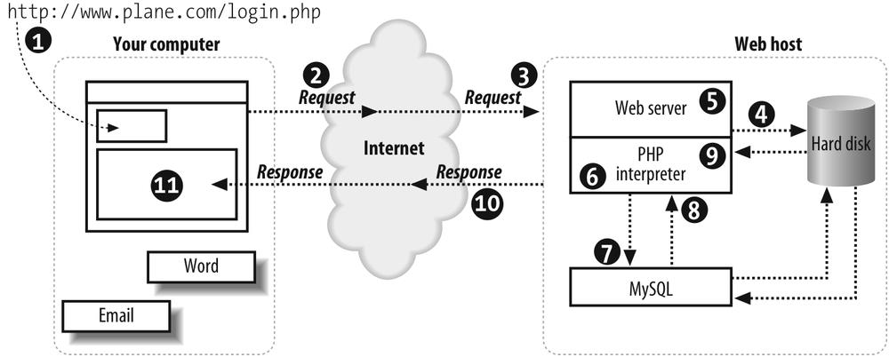

Figure 3: php operation illustration

4.2.3 CSS 3

CSS is simply referred to as Cascading Style Sheets.CSS is used to define styles for web pages, including the design, layout, and variations in the display for different de-vices and screen sizes.

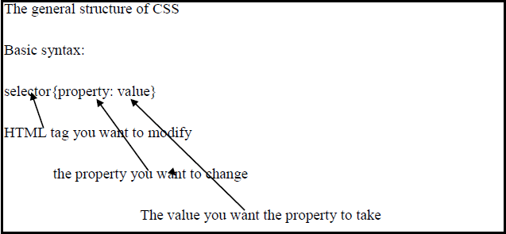

Figure 4: CSS 3 basic structure

4.2.4 MYSQL

MySQL is a free source database system, and it enables the cost-effective delivery of reliable and a high-performance and scalable Web-based and embedded database applications. It is a relational database system (RDBMS). It is a high performing program and scalable to meet the demands of users and data. MySQL is written in C and C++, so it is compatible with most of the operating systems available around the world.

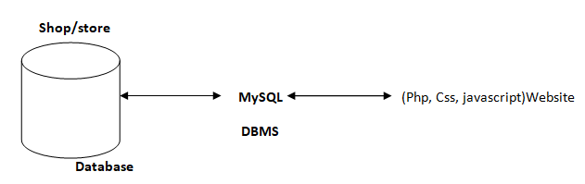

Figure 5: structured query language diagram

## 4.3 PROTOTYPE DESING

Below is a simple prototype of the proposed system.

Product 3

Product 2

Product 1

Products valilable

Navigation bar

Main logo

## 4.4 PROCESS FLOW

4.4.2 Login Module

The customer will use his particular data e-mail and password to log into the shop. After submitting the form, the html5 checks if all the fields have been filled correctly. If the condition is not met the customer remains on the same page but if the fields are correctly filled the customer login information is sent to the database to check if the data entered into the areas are same as the ones used to register to the database. If it is correct the customer is redirected to his homepage, and he can successfully pick products and check out if they are done shopping. Figure 7 shows the flow diagram of customer log-in.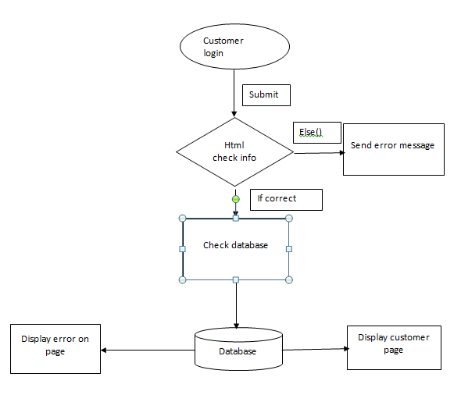

Figure 6: login module

4.4.2 Output Design

This is a view of the products after they have been put into the database. It appear in a table form allowing the user to change any products or delete any product he or she wishes

|  |  |  |  |  |  |  |  |  |
| --- | --- | --- | --- | --- | --- | --- | --- | --- |
| VIEW PRODUCTS | | | | | | | | |
| Product ID | Product Title | Product Image | Product Price | Product Sold | Product Keywords | Product Date | Product | Product Edit |
| 1 | ITEM 1 |  | Price(ksh) | 1 | Value x | date | Delete | Edit |
| 2 | ITEM 2 |  | Price(ksh) | 20 | Value x | date | Delete | Edit |
| 3 | ITEM 3 |  | Price(ksh) | 30 | Value x | date | Delete | Edit |
| 4 | ITEM 4 |  | Price(ksh) | 4 | Value x | date | Delete | Edit |
| 5 | ITEM 5 |  | Price(ksh) | 7 | Value x | date | Delete | Edit |

4.4.3 Actors of the system

#### Admin.

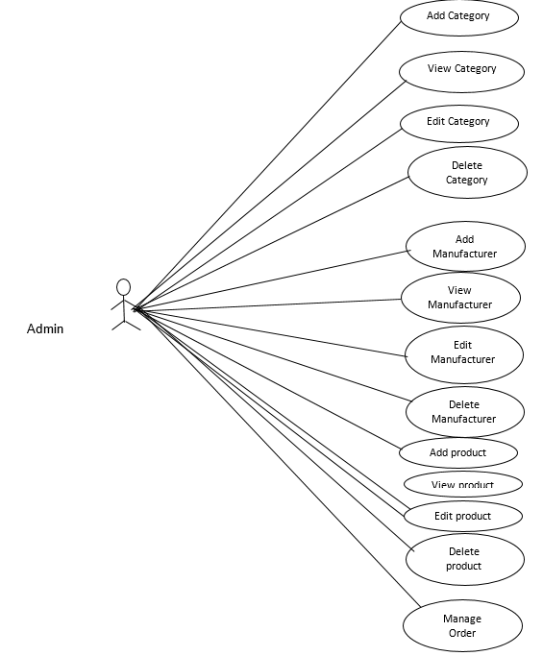

Figure 7: actors of the system - admin

As indicated above the admin has full control of the system. He or she can

* Manage orders from customers e.g. verifying if they have been paid for.
* Delete products from the system if they are outdated or are out of stock.
* The admin can edit products e.g. names etc.
* The admin can delete view or add manufacture details.
* The admin can edit , delete or view customer details.

#### Customer.

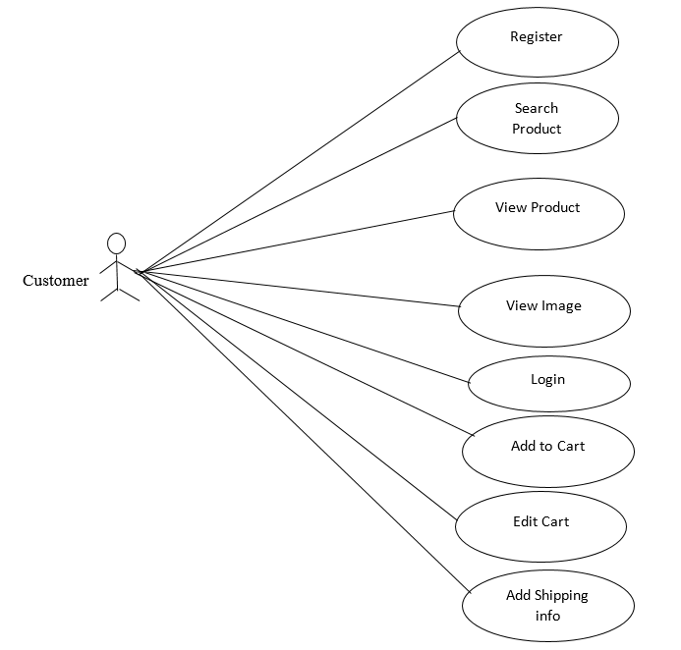

Figure 8: actors of the system - customers

The customer will be able to performer the following activities in the proposed system

* Register as a new user if he or she doesn’t have an account
* Browse through products.
* View different products available
* View images
* Login and out as he or she wishes
* Add items to cart
* Edit cart e.g. delete items

## 4.4 ENTITY RELATIONSHIP DIAGRAM

An ER diagram can be used to design logical database schemas. An ER model is a high-level. Description of the data and the relationships among the data, rather than how data is stored. It focuses on identifying the entities and the relationship among the entities. In the ER diagram of Online Shopping the relationship between the customers to product is one to many as one customer can buy multiple product, also the relationship between category to products is one to many since a single category entails different products. Below is the ERD used in the proposed system

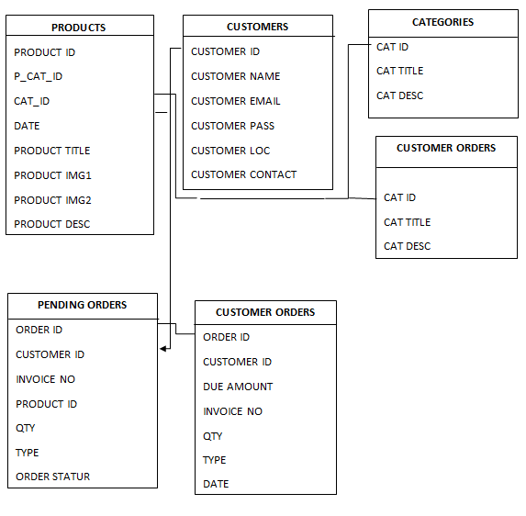

## 4.5 SYSTEM OVERVIEW

DFDs are often used as a preliminary step to create an overview of the system, which can later be elaborated. A data flow diagram (DFD) is a graphical representation of the "flow" of data through an information system, modeling its process aspects. Below are some of the dataflow diagrams used during the design of the proposed system.

4.5.1 Context level diagram

Below is a context level diagram showing task happening in the whole system in general; the basic input and output.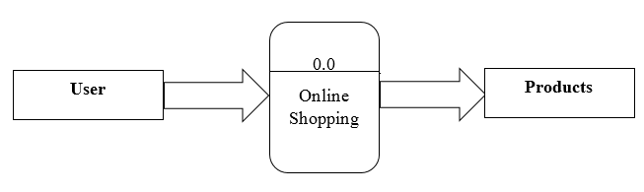

Figure 9: context level flow diagram DFD

4.5.2 First level DFD

First level DFD shows the major steps that have to complete to buy a product. Initially customer visit the website, search the product by category, and show the product, select payment method and finally the product delivered by the company agent.

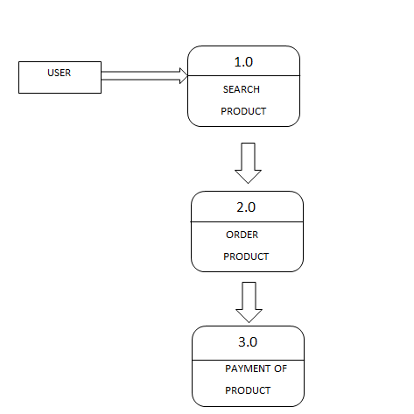

Figure 10: first level DFD illustration

4.5.3 Second level DFD

The second DFD illustrated bellow shows in details the different processes that take place in the proposed system.

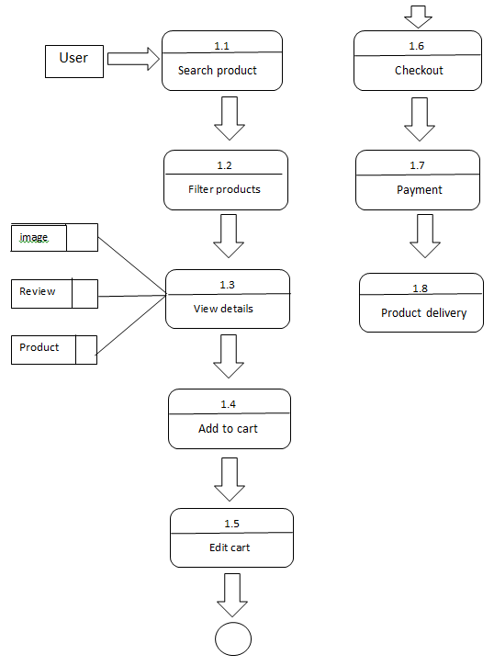

Figure 11: Second level DFD illustration

## 4.6 SYSTEM INTERFACE

4.6.1 Customer interface

#### Home page.

A home page is a webpage that serves as the starting point of website. It is the default webpage that loads when visit a web. The home page is located in the root directory of a website. Most web server allows the home page to have one of several different filenames. Examples include index.html, index.htm, index.shtml, index.php, default.html, and home.html. The default filename of a website's home page can be customized on both Apache and IIS servers. Since the home page file is loaded automatically from the root directory, the home page URL does not need to include the filename. There is no standard home page layout, but most home pages include a navigation bar that provides links to different sections within the website.

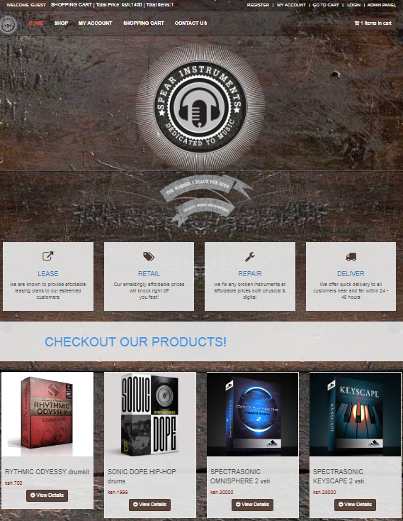

Figure 12: login interface

#### Customer login and registration page.

Customer have to login before adding product in cart. In this page existing customer can login

to buy product and new user can create an account for buying the product. Figure of user login

and registration page given below:

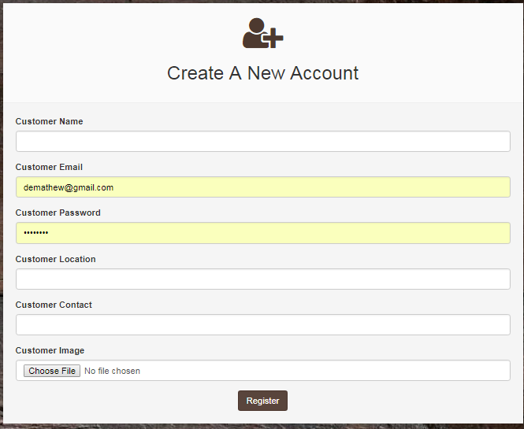

Figure 13: customer registration page

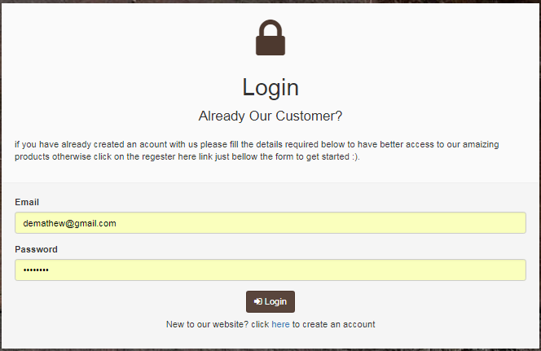

Figure 14: customer login page

## 4.7 OPERATIONALIZATION OF THE SYSTEM

The system basic operations are illustrated in the diagram below.

## 4.8 EVALUATION AND SYSTEM TESTING

Testing was based on two major units, customer/user and Management Units. The customer test proved that an account could be created and could be logged into. The cart could be loaded with products and the customer could checkout after shopping. The test also verified that an administrator could create an account and log successfully. After login in it was verified that admin could manage all the content in the shop i.e. by performing operations such as adding products and editing them , managing users I.e. by adding and deleting them , adding and editing products as well as deleting them etc.

4.8.1 Shopping Cart testing

Some quantity of products was inserted into the shopping cart, and then I proceeded to check out. When I checked out and placed and order the cart reset to zero items, awaiting for user again. This indicated that the cart works appropriately as it should. The "*cart.php*" file is responsible for handling the cart of the shop. When an editor runs the file "*cart.php*" the *cart()* function is called which inserting products into the database. After that, the view *cart()* function is invoked to show the product in the cart. The customer can manipulates his cart e.g. by updating the cart or, adding a product to cart.

4.8.1 Customer Checkout testing

The customer can only check out if he has logged in as a customer. The system does not allow the user view order and checkout pages if he or she is not registered into the system as a customer but he or she can view different product before deciding whether he or she would like to create an account with the proposed system or not.

For a customer with an account, he or she logs in and is redirected to the orders placed right after checking out. He then pays for the product and awaits delivery.

Below are a sample test result for an order placement and successful payment.

## 4.9 RESULTS AND ANALYSIS

Testing was based on two major units, customer/user and Management Units. The customer test

Various areas were put in consideration as they were the major objectives of the proposed system. And through various techniques the analyst was able to come up with conclusive results: namely

### 4.9.1 Accuracy of the current system

|  |  |  |
| --- | --- | --- |
| Response on accuracy | Number of people | Percentage |
| Good | 5 | 10% |
| Fair | 15 | 21% |
| Bad | 52 | 72% |
| Total number | 71 | 100% |

Figure :accuracy off current system

### 4.9.2 Bar chart on the current system

Figure : bar chart of the current system

### 4.9.3 Pie chart on the current system

Figure :pie chart on accuracy of current system

The current system is extremely slow as per results that the analyst gathered from his research.

|  |  |  |
| --- | --- | --- |
| Response on speed | Number of people | Percentage |
| Fast | 6 | 8.4% |
| Slow | 14 | 19.7% |
| Very slow | 47 | 66.1% |
| Not sure | 4 | 5.6% |
| Total number | 72 | 100% |

Figure : analysis of current system

4.2.2.1 Pie chart for the current speed

Figure : speed of current system pie chart

Bar graph speed of the current system

Figure : bar chart on speed of the current system

### 4.9.3 Level of security of the current system

Security was another area that the analyst considered during his research and found that data insecurity was very high.

|  |  |  |
| --- | --- | --- |
| Response on security | Number of people | Percentage |
| Secured | 16 | 22 |
| Not secured | 48 | 68 |
| Very secured | 6 | 8 |
| Not sure | 1 | 4 |

Figure : table on level of security of the current system

# CHAPTER 5

# SUMMARY CONCLUTION AND RECOMENDATIONS

## 5.0 INTRODUCTION

In this chapter recommendations summary and conclusions of the research are offered on the effects, challenges and importance of different retailer taking their products online in Limuru and Nairobi town.

## 5.1 SUMMARY

The study found that there were allot of businesses that had no online presence and were not growing as fast as those that had their product s online and different buyers could view and purchase their products without one on one interaction .it was also gathered that those businesses that were not online could not reach a wider market computer to those businesses that had. Advancement in Technology was found out to be one of the main tools that business use to gain competitive edge. Innovations contributed highly to different online businesses using methods such as product rating and customer commenting on different products they have purchased creating a scene of trust between different customers and retailers and enabling buyers to make better well informed descriptions before purchase.

It was identified that not all organizations and small business trained their staff on how online businesses operate and therefor e this businesses lost those that trained their employees through skilled personel.it was also noted that businesses that used advanced transaction methods such as PayPal gained more competitive edge compared to those who didn’t as they were able to reach wider market with potential customers.it was identified that computerizations made a big difference to businesses and the society In general. Computerization enabled saving of space taken by manual materials, it increased efficiency and accuracy, it enabled easier storage and update of different recorded and offered better security from unauthorized users.

It was identified that there was faster response time for online businesses as many customers in different locations are catered for and feedback was offered promptly via emails e.g. after customer made orders for the products they needed.it was also gathered that online businesses reduced on some of the operational costs such as purchasing stock books and cabinets and less staff was needed since only persons with administrator privileges could update stock records thus reducing fraud

.

## 5.2 CONCLUSIONS

The study concludes that businesses that have their products online have better chance of survival compared to businesses that don’t. Online businesses also experience different challenges such as mismanagement e.g. when the target users are not trained properly. Fraud cases are also experienced by some customers from conmen and fake websites. The study concludes that ICTs provides reliable access to markets. ICT allows reduction in transactions costs, improved access to timely and usable knowledge, improved communications with markets and within supply chain, acquisition of appropriate skills for enhancement of productivity and improved information about new opportunities. New technologies create new markets and opportunities.

The study concludes that innovation is one of the main tools that gives business a competitive edge compared to other businesses. The study also concludes that creating trust between retailers and customers is key done through allowing customers to comment on products and rate the products enabling different customers make better decision when purchasing different products.to add to this the study concluded that using universal payment methods such as papal widened the market for businesses can transact with businesses and potential customers outside the country

The study concluded that online businesses should be more keen on issues of security , customer credentials have been used before by unauthorized users such as credit card numbers that create mistrust and slowed down the process off online business growth.

## 5.3 RECOMENDATION

The study recommends that businesses aim at putting their products online in order to gain more customers as they will be able to reach a wider market. The study also recommends that businesses tighten their security both at the front end and back end to prevent persons with malicious intent from damaging their business and their relationship with customers. The study recommends that businesses embrace and incorporate technology in order to improve efficiency and reduce operational costs and also take advantage of other benefits that come with it such as easy update of records , faster response to customer needs and enable them to create new market opportunities

The study recommends that officials and managers invest on training their staff using qualified personnel to enable them takes advantage of opportunities that online marketing offers. The study also recommends that businesses should encourage creativity and innovation in order for them to gain a higher competitive edge in their businesses that will help them and the economy grow.

## 5.3 SUGGESTIONS FOR FURTHER RESERCH

Persons interested in carrying out similar research can use the references outlined below. The study focused on the effects, challenges and importance of different retailer taking their products online

# REFERENCES

en.wikipedia.org/wiki/Online_shopping_case_management

Beginning PHP5 (wrox) ISBN 81-265-0539-7

Database System Concept By Silberschartz, koth, Sundarshan ISBN 007-124476-X

www.w3schols.com

http://www.siteground.com/tutorials/php-mysql/zend_optimizer.htm

http://php.net/manual/en/tutorial.php

<https://www.mysql.com/>

/1/www.w3school.com

/3/CSS3 characteristic and attributes 3.05.2018

/2/php features. 08.03.2018

http://www.biogem.org/downloads/notes/PHP%20-%20Hypertext%20Preprocessor.pdf/4/Javascript academic. Accessed 09.03.2018

/4/http://www.w3schools.com/js/default.asp

https://dev.mysql.com/doc/apis-php/en/apis-php-pdo-mysql.html

/5/Documentation for mysql/ 05.01.2018

/6/UML idea. access 1.05.2018

https://en.wikipedia.org/wiki/Unified_Modeling_Language

/7/XAMPP 2.05.2018

https://www.apachefriends.org/index.html

/9/PhpMyAdmin. 5.05.2018

https://www.phpmyadmin.internet/

/8/Bracket editor 5.05.2018

https://en.wikipedia.org/wiki/Brackets_(text_editor)

/10/PayPal developer and Sandbox account 5.05.2018

https://developer.paypal.com/developer/accounts/

/11/The basic diagram of the HTML/HTML5 5/24/2018

44

http://www.modelrumahminimalis.co/html-menu-templates-free-download/69033.html/top-result-html-menu-templates-free-download-inspirational-generous-menu-template-html-images-entry-level-resume-templates-picture-2017-hdj5

/12/Demonstrating how the web server Operates using PHP5/24/2018

https://www.safaribooksonline.com/library/view/learning-php-and/0596101104/ch01s04.html

# APPENDICES

## Appendix 1: Questionnaire

#### Questionnaire for data collection to employee

MUSIC ECOMERECE WEBSITE

QUESTIONNAIRE

TO : MELODICA MUSIC STORE WORKERS.

EMPLOYEE NAME : MADAM WANJAA.

PURPOSE : TO HELP IN THE STUDY OF THE CURRENT SYSTEM IN

ORDER TO COME UP WITH A NEW AUTOMATED SYSTEM.

INTRODUCTION:

The researcher is a student at The Kabete National Polytechnic taking a diploma in information technology. The researcher is meant to determine the services offered in the melodica music store. This is for academic purposes only and prerequisite for partial fulfillment of the award of a diploma by the Kenya national examination council (**KNEC**)

I therefore kindly request for your participation in this study. Any assistance is highly appreciated in advance and all information will be treated with confidentiality.

STUDENT NAME: SPEAR NJOROGE

Please read the following questions and answer them correctly.

Use a Y [ Y ] for yes and a cross [ X ] for nowhere necessary.[ - ]

1. What is the current system in use in the Organization?

Manual [ ] Semi-computerized [ ] Computerized [ ]

1. What is your opinion on the accuracy of the system in terms of record and reports produced by the system?

Accurate [ ] Very accurate [ ] Not accurate [ ]

1. Does the current system guarantee security of information?

Yes [ ] NO [ ]

1. What method is used when creating an order?

…………………………………………………………………………

1. Would you recommend a change of the current system?

Yes [ ] NO [ ]

Appendix 2: Interview

**Interview to manager**

MUSIC ECOMERECE WEBSITE

INTERVIEW

TO : THE MANAGER

MANAGER NAME : MR MAINA

PURPOSE : TO HELP IN TE STUDY OF THE CURRENT SYSTEM IN

ORDER TO COME UP WITH A NEW AUTOMATED SYSTEM

INTRODUCTION:

The researcher is a student at The Kabete National Polytechnic taking a diploma in information technology. The researcher is meant to determine the services offered in the melodica music store. This is for academic purposes only and prerequisite for partial fulfillment of the award of a diploma by the Kenya national examination council (**KNEC**)

I therefore kindly request for your participation in this study. Any assistance is highly appreciated in advance and all information will be treated with confidentiality.

STUDENT NAME: SPEAR NJOROGE

**REQUIRED.**

**PLEASE ANSWERE ALL THE QUESTIONS.**

1. What is the current system in use?
2. What are the main activities carried out in the Organization?
3. How do you keep and update records?
4. What challenges do you encounter when performing the job operations?
5. To what extent is your business computerized

* Are you connected to the internet yes [ ] No [ ]
* Do you have a website for your instruments yes [ ] No [ ]
* Do you use Mpesa or PayPal for transactions yes [ ] No [ ]

1. What are your conclusions about the current system?

Appendix 3: Interview

**Interview to Artist**

MUSIC ECOMERECE WEBSITE

INTERVIEW

TO : ARTIST

ARTIST NAME : JAMES MAINA

PURPOSE : TO HELP IN TE STUDY OF THE CURRENT SYSTEM IN

ORDER TO COME UP WITH A NEW AUTOMATED SYSTEM

INTRODUCTION:

The researcher is a student at The Kabete National Polytechnic taking a diploma in information technology. The researcher is meant to determine the services offered in the melodica music store. This is for academic purposes only and prerequisite for partial fulfillment of the award of a diploma by the Kenya national examination council (**KNEC**)

I therefore kindly request for your participation in this study. Any assistance is highly appreciated in advance and all information will be treated with confidentiality.

STUDENT NAME: SPEAR NJOROGE

**REQUIRED**

**PLEASE ANSWERE ALL QUESTONS.**

1. What challenges do you encounter as an artist?
2. How is your information being kept at melodica music store?
3. What steps do you follow when placing an order for a musical instrument at melodica.
4. What are the recommendations about the system in use?

Appendix 4: resources

### HARDWARE RESOURCES

1. A computer with a HDD capacity of at least 500 GB

This will be used to enter data process the data and then store data as farmers

1. Printers to be used to print the various details needed at times.
2. At least an internet enabled phone to be used by farmers
3. Flash disk for temporary storage of files.
4. Paper for printing out hard copies of documents.

### SOFTWARE RESOURCES

1. MS office to enable data manipulation.
2. Antivirus software.
3. An operating system that supports GUI (graphical user interface).
4. An internet enabled mobile phone with either of the following operating system: iphone, symbian s60, symbian UIQ, blackberry OS, Android.
5. Text editor for designing
6. Jquery:1.8.2
7. Jquery mobile:1.2.0
8. Ripple emulator

Appendix 5: Budget

Table : budget

|  |  |
| --- | --- |
| **PROJECT EXPENSES** | ***AMOUNT*** |
| System requirement expenses | **5,000.00** |
| Computer and mobile phone | **40,000.00** |
| Computer softwares | **10,000.00** |
| Research and users training expenses | **10,000.00** |
| Emergency expenses | **5,000.00** |
| **Total expense** | **65,000.00** |

**Table 3 Budget**

**Budget justification**

The project requires Kshs 75,000 broken down as follows:

1. System requirement expenses: These expenses are incurred during the gathering of facts such as interviews and observation.
2. Research expenses: these are expenses incurred during the research they include internet expenses, transport.
3. Computer software: Operating systems, utilities, anti-viruses.
4. Emergency expenses they include expenses that are not anticipated for.

Appendix 5: Implementation schedule

Table 4: schedule

|  |  |  |  |  |  |  |  |  |  |  |  |  |  |  |  |  |  |  |  |  |
| --- | --- | --- | --- | --- | --- | --- | --- | --- | --- | --- | --- | --- | --- | --- | --- | --- | --- | --- | --- | --- |
| **Task Name** | **Duration in weeks** | | | | | | | | | | | | | | | | | | | |
|  | **1** | **2** | **3** | **4** | **5** | **6** | **7** | **8** | **9** | **10** | **11** | **12** | **13** | **14** | **15** | **16** | **17** | **18** | **19** | **20** |
| Research & project planning |  |  |  |  |  |  |  |  |  |  |  |  |  |  |  |  |  |  |  |  |
| Proposal writing and submission |  |  |  |  |  |  |  |  |  |  |  |  |  |  |  |  |  |  |  |  |
| Data collection |  |  |  |  |  |  |  |  |  |  |  |  |  |  |  |  |  |  |  |  |
| Data analysis |  |  |  |  |  |  |  |  |  |  |  |  |  |  |  |  |  |  |  |  |
| Project design |  |  |  |  |  |  |  |  |  |  |  |  |  |  |  |  |  |  |  |  |
| Coding |  |  |  |  |  |  |  |  |  |  |  |  |  |  |  |  |  |  |  |  |
| Implementation and debugging |  |  |  |  |  |  |  |  |  |  |  |  |  |  |  |  |  |  |  |  |
| Documentation |  |  |  |  |  |  |  |  |  |  |  |  |  |  |  |  |  |  |  |  |
| Project presentation |  |  |  |  |  |  |  |  |  |  |  |  |  |  |  |  |  |  |  |  |

**Table 5 Ghant chart schedule for the implementation**

Completed